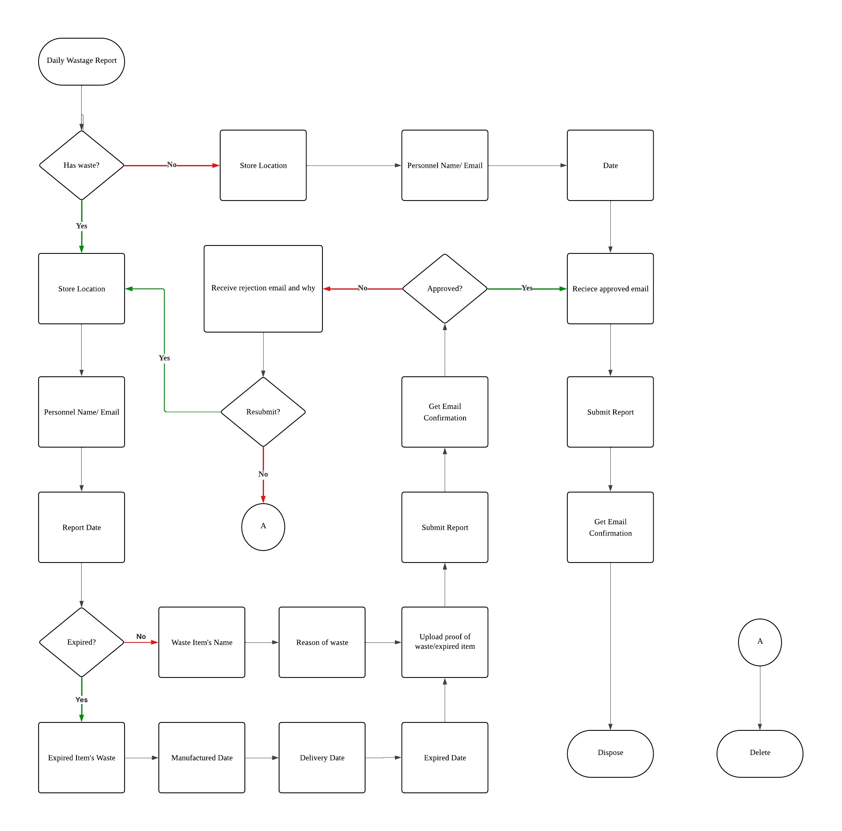

 | ACCESSING WASTAGE REPORTING SYSTEM
● | Open any browser
● | Type  “https://waste-disposal-six. vercel.app” in the URL space provided then hit “Enter” |   
● | After redirecting, it will navigate you to the home/landing page. | 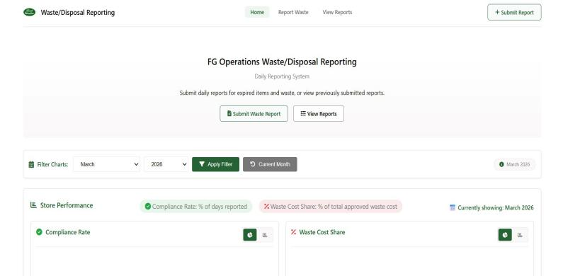
● | Here in the dashboard you can see all of the store’s performance such as compliance rate and waste cost. | 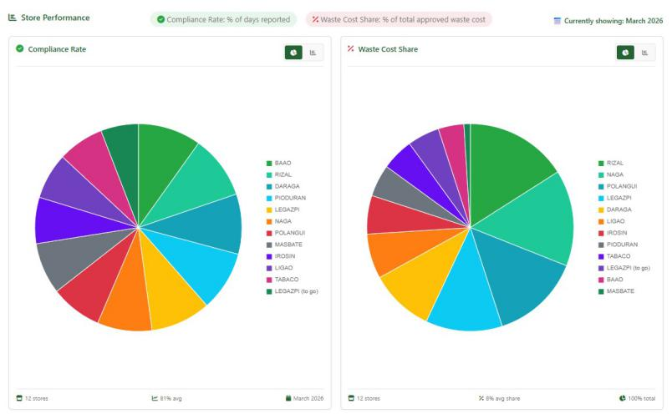
● | Click the submit waste report button to redirect to the waste report submission form. | 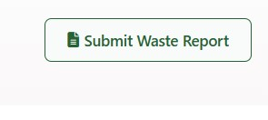

WASTE REPORT SUBMISSION FORM
● For submitting waste report  - Insert email to get email confirmation  - Select assigned store  - Insert name of the submitter  - Input report date | 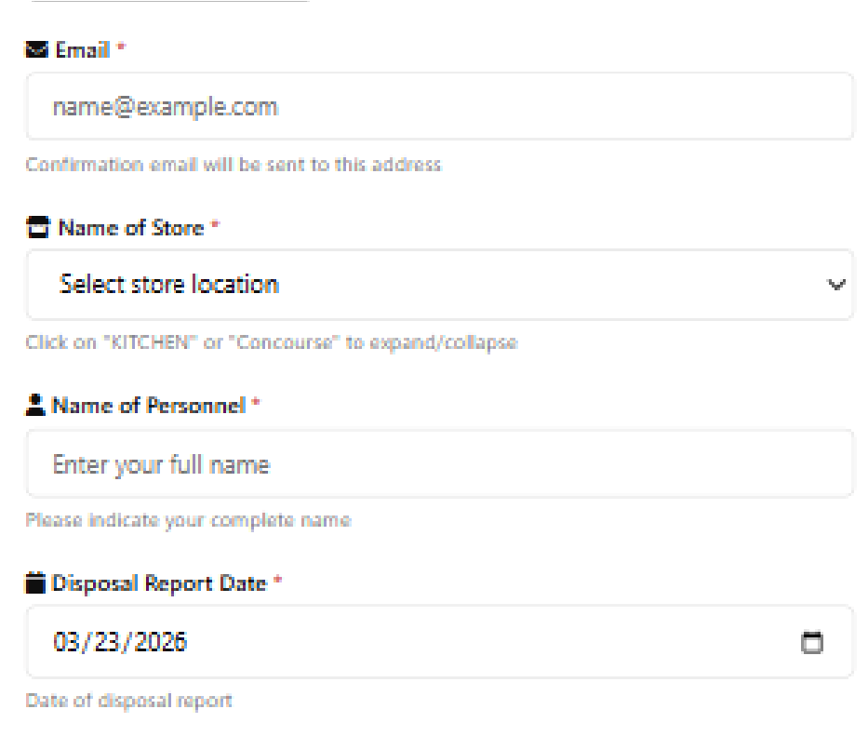
● Select Disposal Type  - Expired items - for submitting expired items.  - Waste - for submitting store wastes.  - No waste - if no waste or expired item for the day | 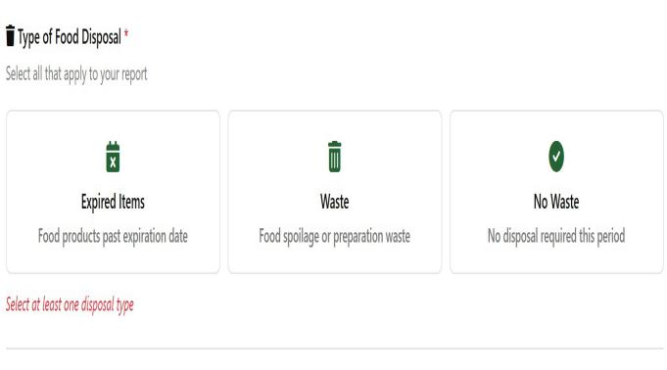
A. Expired Items  ● For expired items fill up form:  - Item Name (expired Item to submit)  - Delivered Date  - Manufactured Date  - Expired Date  - Quantity  - Unit of Measure  - Documentation (Picture of the expired item showing the dates) | 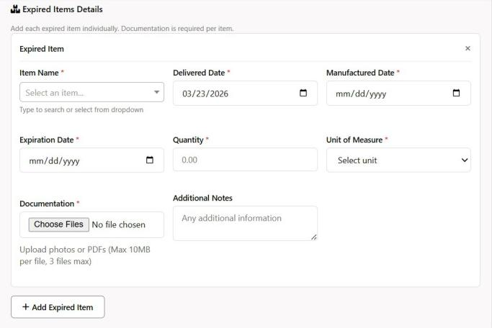

B. Waste Items  ● For waste items fill up form:  - Item Name(waste item to submit)  - Reason for waste  - Quantity  - Unit of measure  - Documentation(Picture of the said waste item)  - Additional Notes (Input reason of waste in detail) | 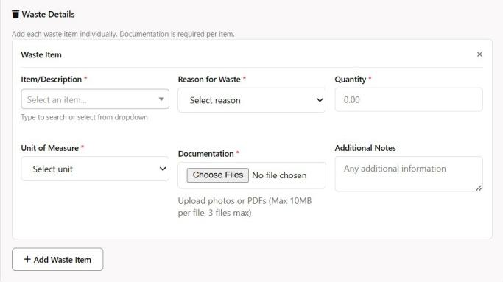
C. No Waste  ● For No waste, no form to fill up. | 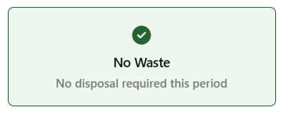
● Click submit report after filling up all the information needed for reporting. | 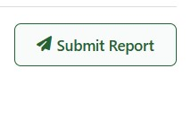
● After submitting a confirmation email will be sent to the email you provided. | 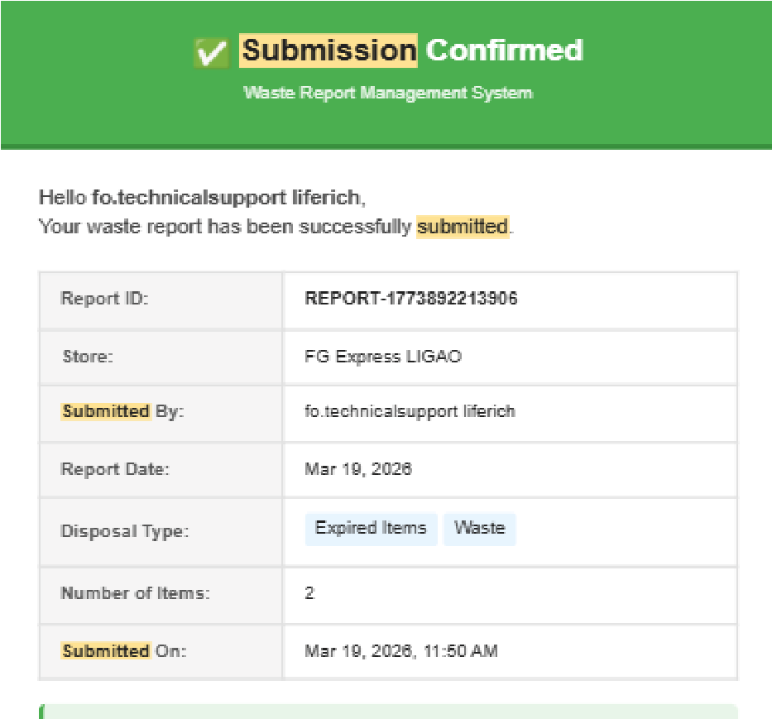

ADMIN DASHBOARD (Viewing, Accepting, & Rejecting of Wastage Reports
● As an Admin/CIA, click the “View Reports” button to display a table listing all wastage reports. | 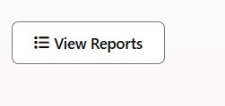
WASTE REPORT DASHBOARD | 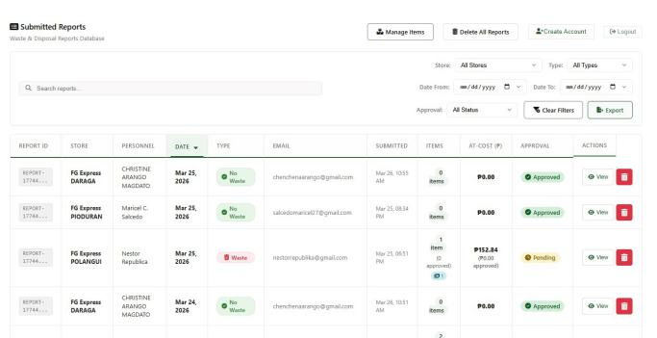
● Search and Filter: This feature allows admin to search for specific wastage reports and apply filters to quickly find the reports they need. | 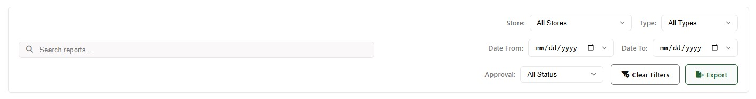
● E-Signature: The Admin can upload or write an E-Signature, which will be used to verify or identify who accepted or rejected a report. | 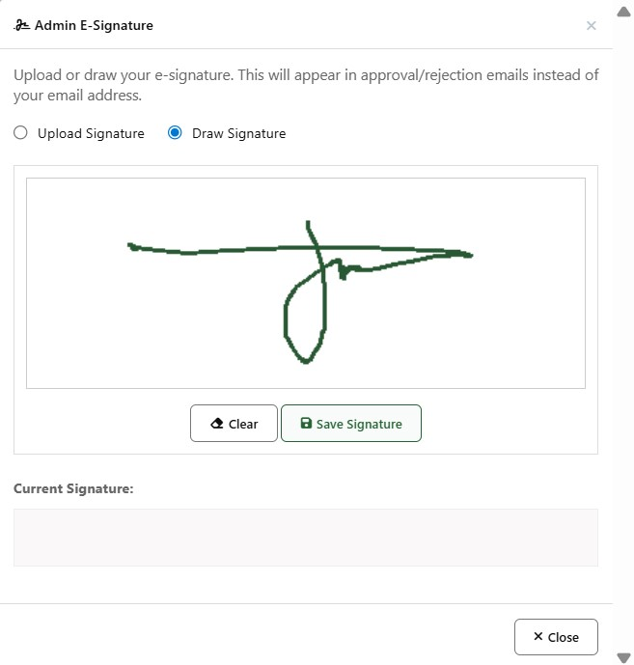

● | Click the Manage Items button to view list of items | 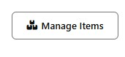
● | View, Edit, or Add Items: The admin can view the existing list of items, make edits to current entries, or add new items to the list as needed. | 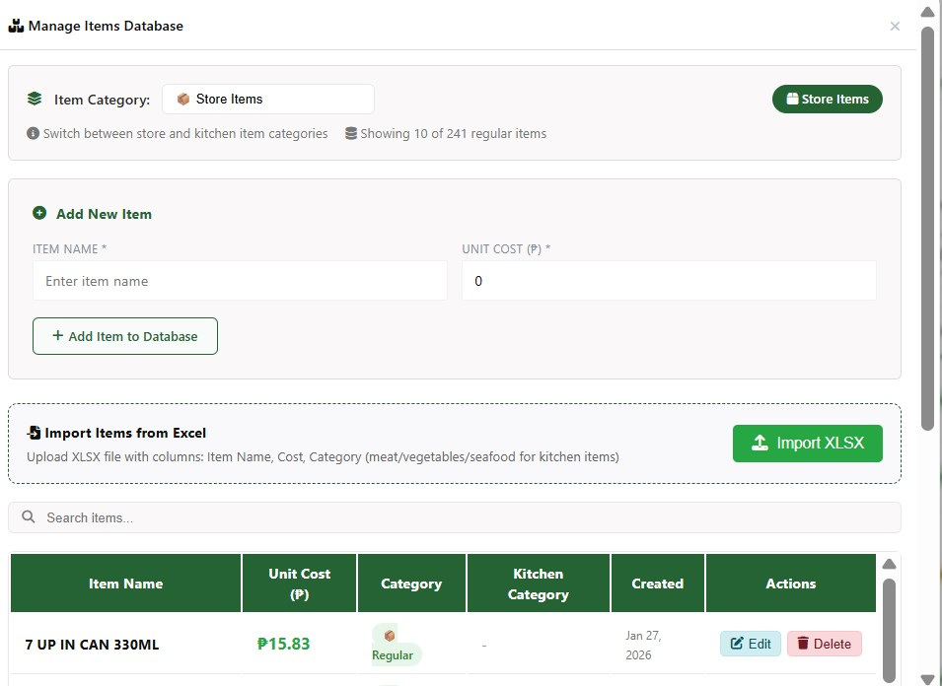
 | WASTAGE REPORT APPROVAL
● | Click “View” on a specific report to open a modal showing its details. | 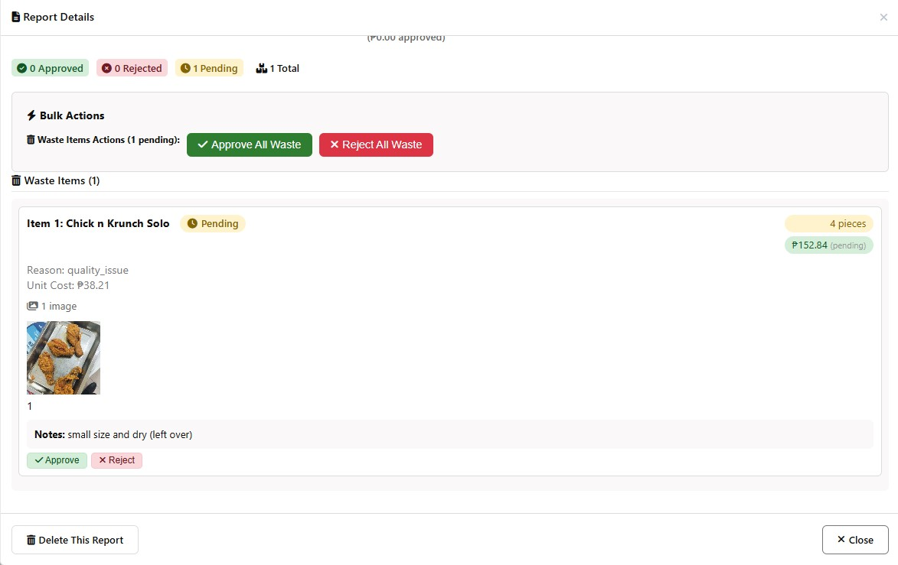
● | After checking the report’s details, the Admin can either:  ACCEPT – Mark the report as Good to dispose.  REJECT – Provide a reason, which will notify the reporter to resend the report. | 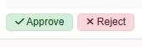  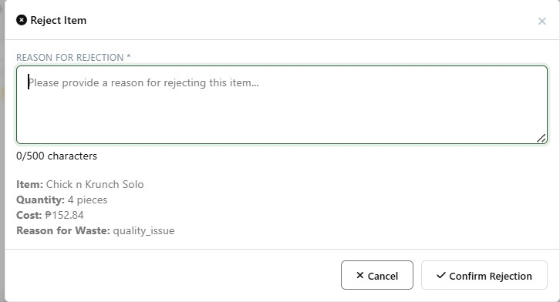

● | Store Performance Overview: The Admin can view each store’s performance, including Total Cost,  Consistency, and Stores Needing Attention, helping identify which stores have the highest wastage and where improvements are needed. | 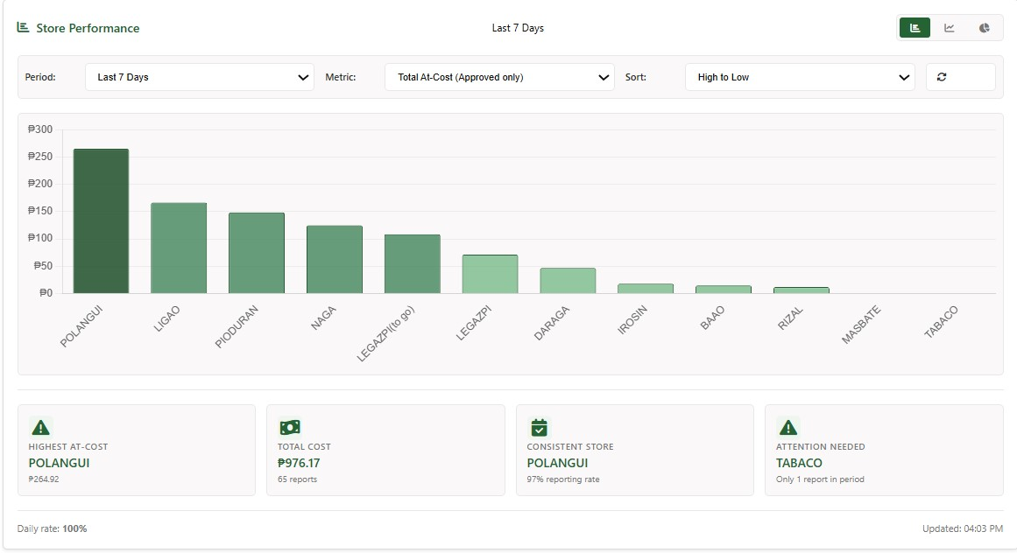
 | WASTAGE REPORT RESUBMISSION (Rejected Items)
● | Report Rejection Notification: When an Admin rejects a submitted report, an email is automatically sent to the submitter containing:  - The details of the rejected item and the reason for rejection.  - A step-by-step guide on how to resubmit the report.  - A “CLICK HERE TO RESUBMIT ITEM” link that automatically redirects the user to the wastage report system. | 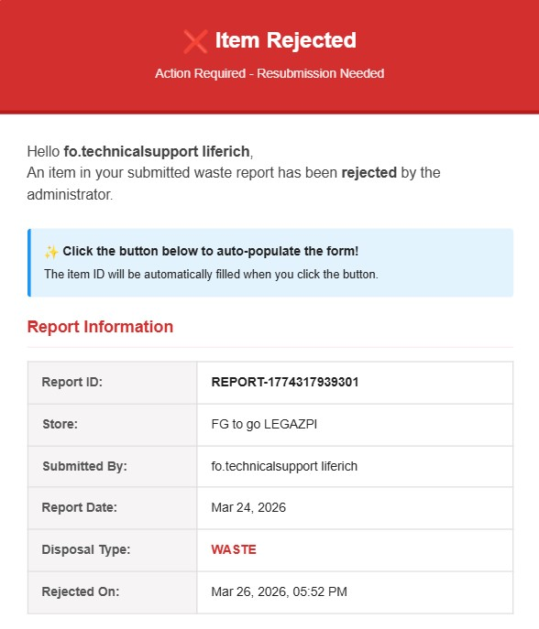  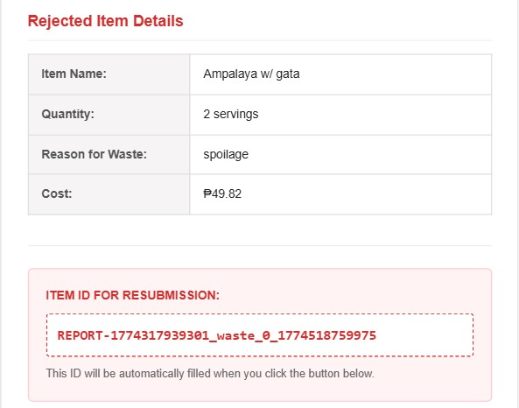

 |  | 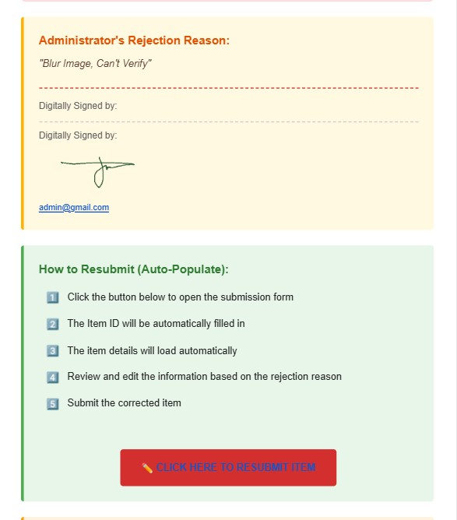
● | After clicking the button, the user will be redirected to the wastage report form, where the previously rejected report will be automatically populated. The user can then review, edit, and correct the rejected report before resubmitting. | 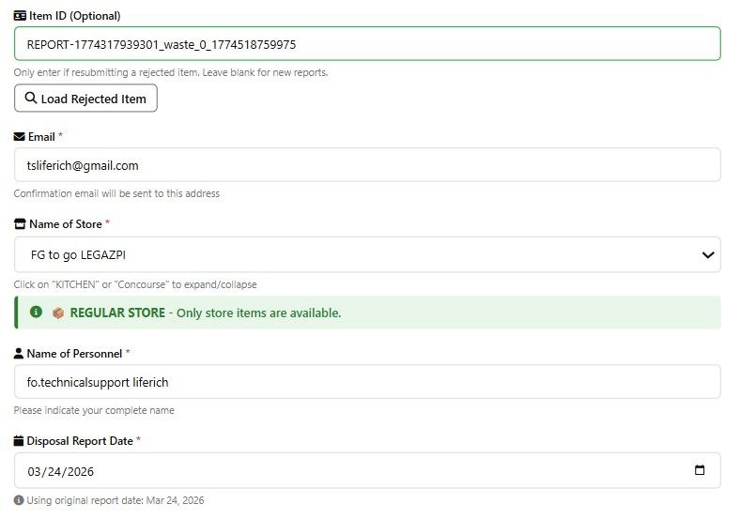  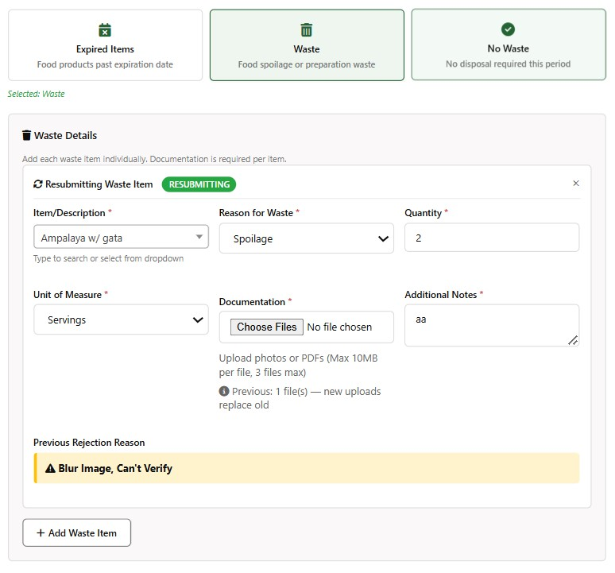

● | Click the Submit Report button again to resubmit the report. | 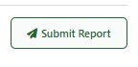
● | After successful resubmission, the user will receive an email confirmation containing the resubmission details. | 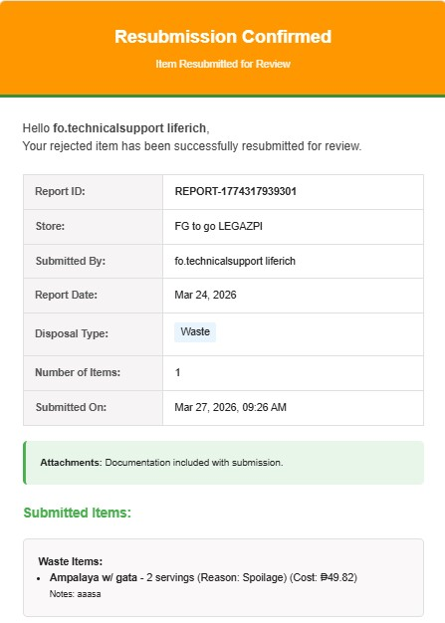  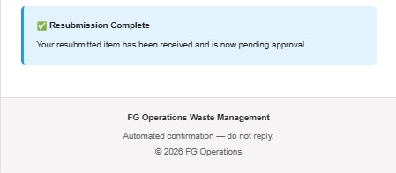
● | The Admin can now recheck the resubmitted item and take action to Accept or Reject it again. | 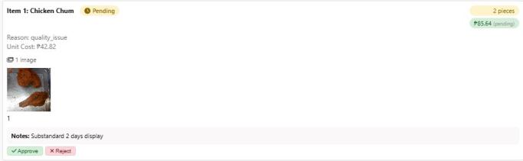
ACCEPTED WASTAGE REPORT
● Once accepted, the submitter can now dispose the approved items. |  | 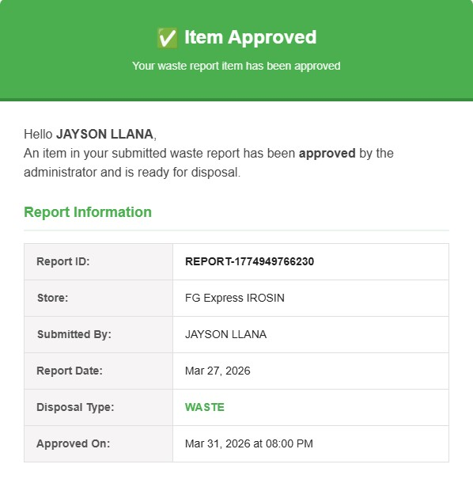  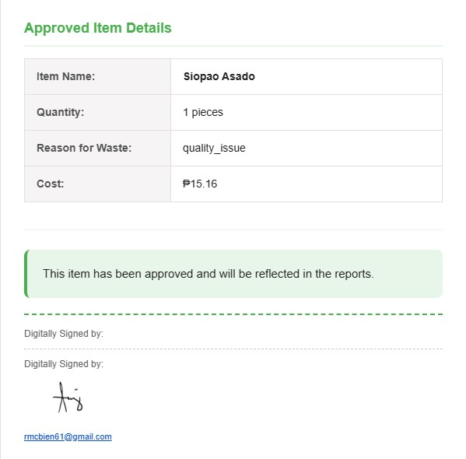

Prepared by:
MCBIEN RICAFORT | JOHN REY R. DADO
Specialist, Inventory Compliance Audit – Food Operations | Technical Support Specialist – Food Operations
Reviewed By: | Recommending Approval:
MARYJANE MARINDA | ARCHIE MARTIREZ
Assistant Manager, Food Operations - ALMASOR | Manager, Food Operations
Approved by:
RONEL PIDA | ROMEO S. TAN
Finance Controller-Services, EO, Corporate and EXCL | Executive Director

